## Manage posts

* + - Login to the system as admin
    - Go to Admin Management page
    - Click on “Bài đăng” tab

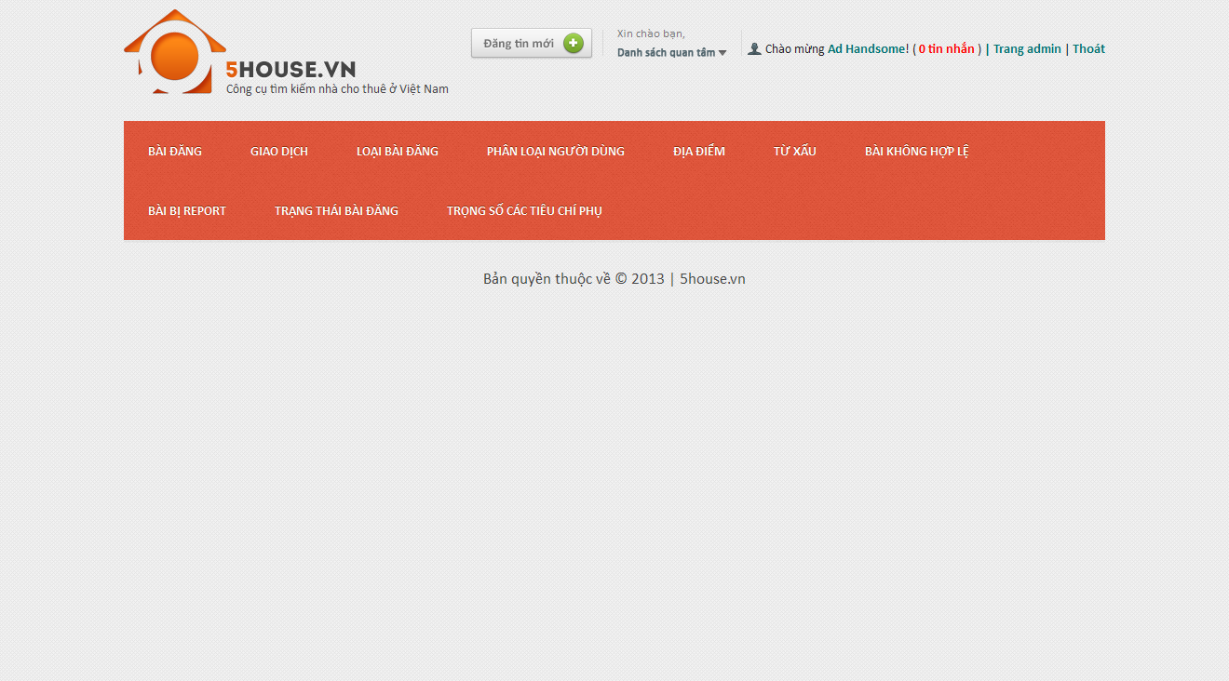

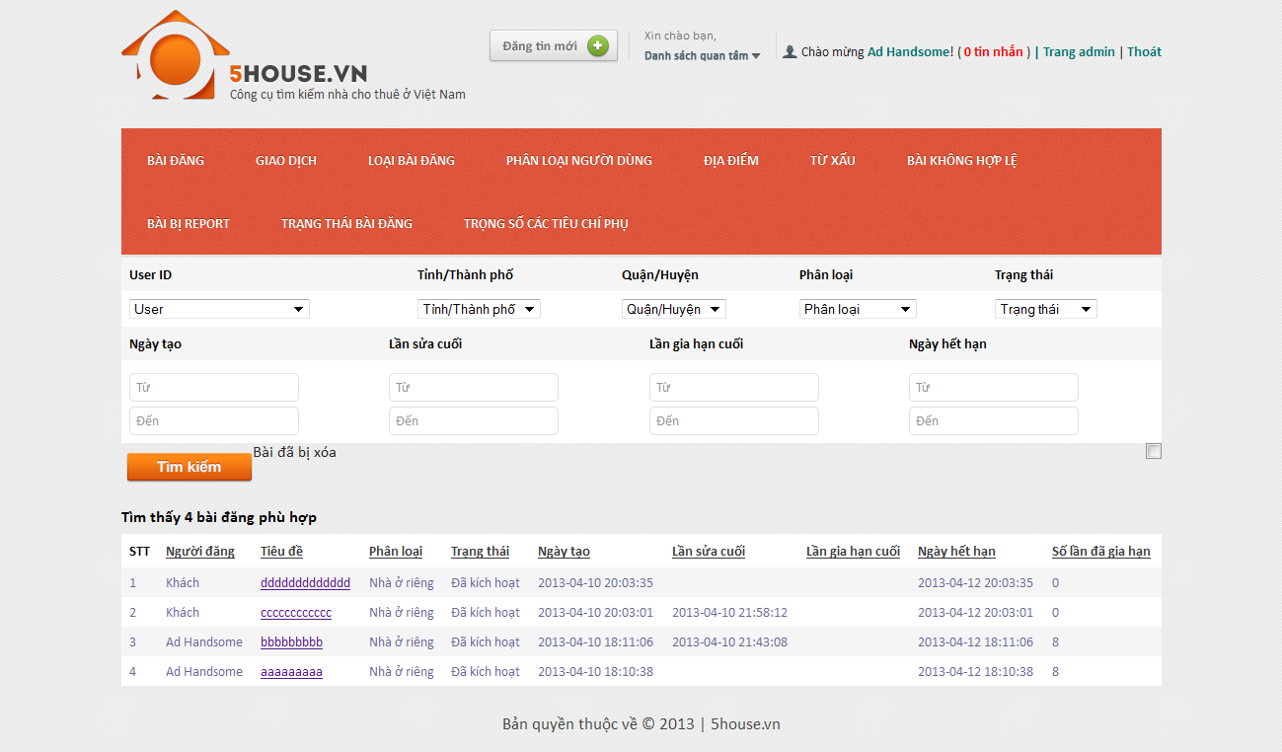

## Manage payments

* + - Login to the system as admin
    - Go to Admin Management page
    - Click on “Giao dịch” tab

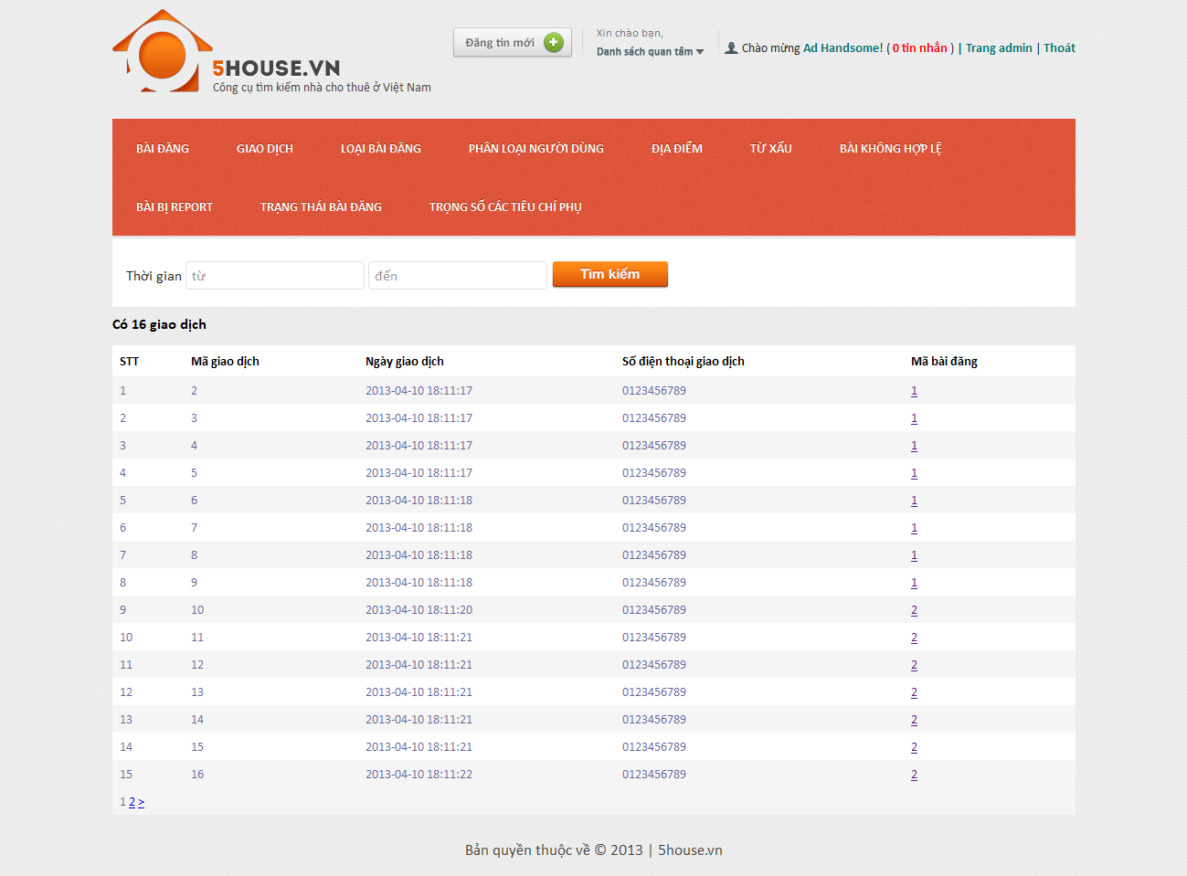

## Manage post categories

## View categories list

* + - * Login to the system as admin
      * Go to Admin Management page
      * Click on “Loại bài đăng” tab

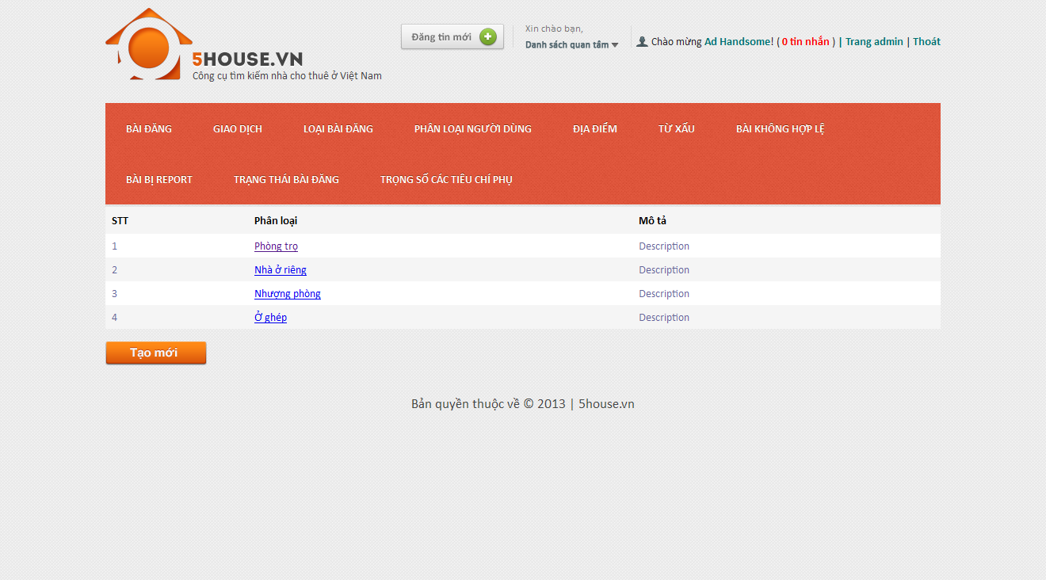

## Create new category

* + - * Login to the system as admin
      * Go to Admin Management page
      * Click on “Loại bài đăng” tab
      * Click on “Tạo mới” button
      * Enter details as prompted
      * Click on “Tạo mới” button

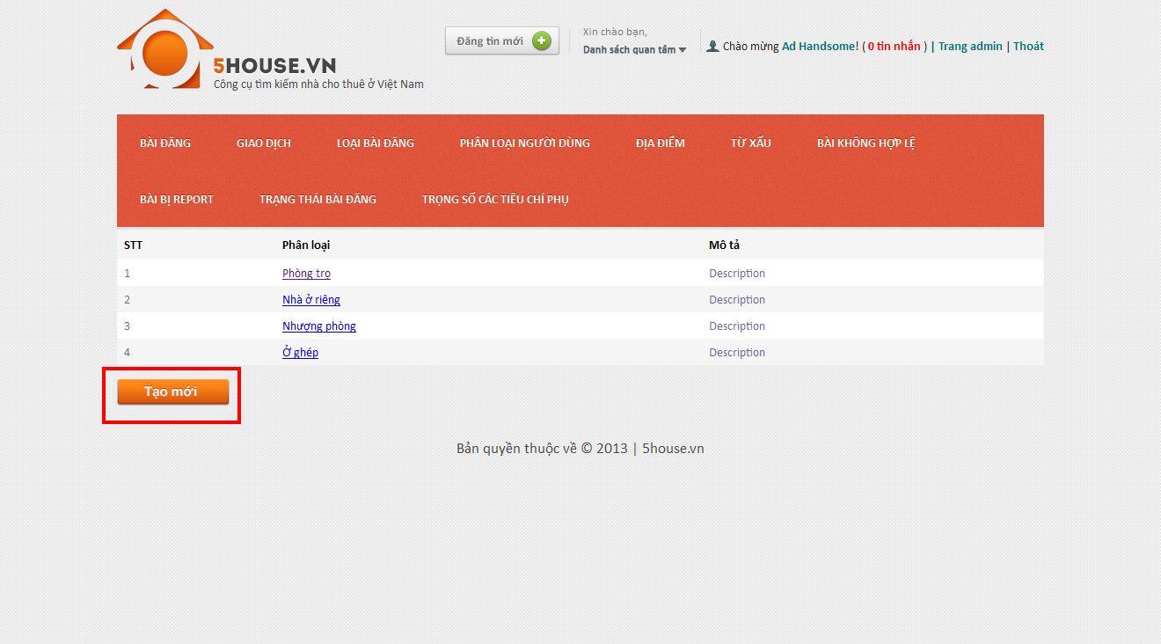

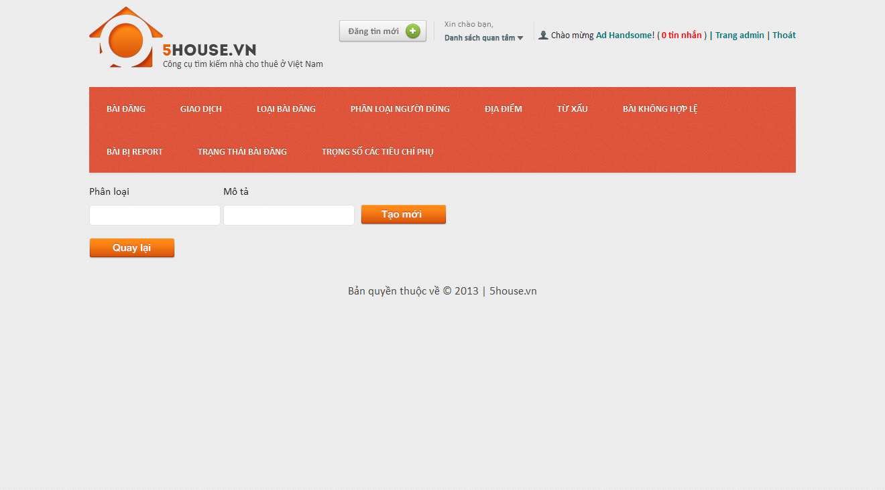

## Edit category

* + - * Login to the system as admin
      * Go to Admin Management page
      * Click on “Loại bài đăng” tab
      * Click on an item on the table
      * Modify details
      * Click on “Lưu thay đổi” button

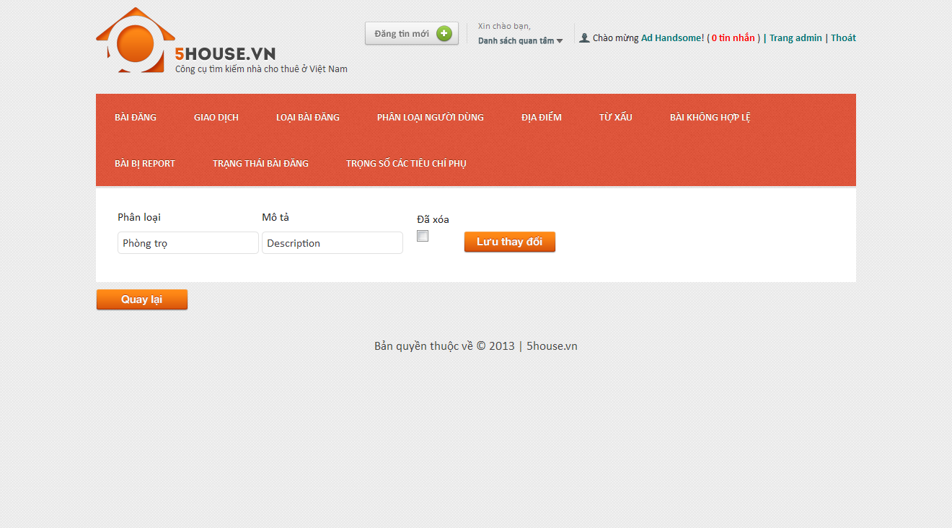

## Manage user roles

## View roles list

* + - * Login to the system as admin
      * Go to Admin Management page
      * Click on “Phân loại người dùng” tab

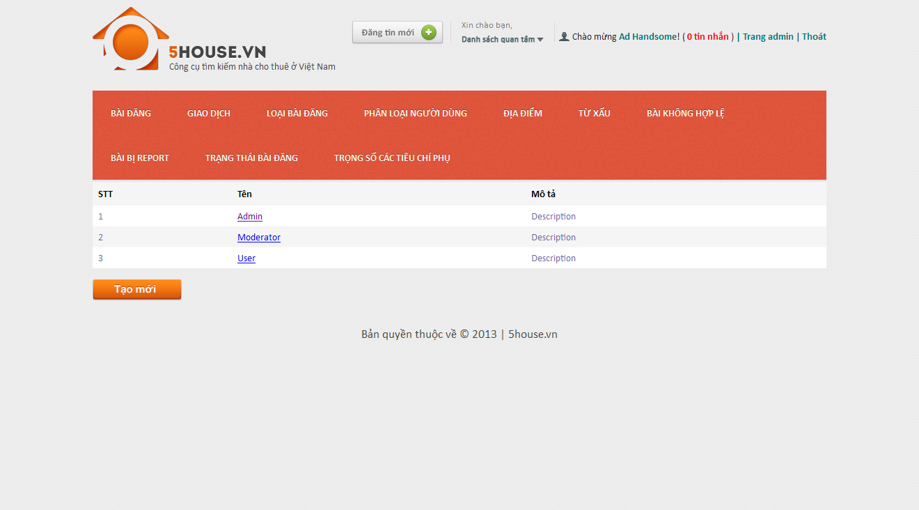

## Create new role

* + - * Login to the system as admin
      * Go to Admin Management page
      * Click on “Phân loại người dùng” tab
      * Click “Tạo mới” button

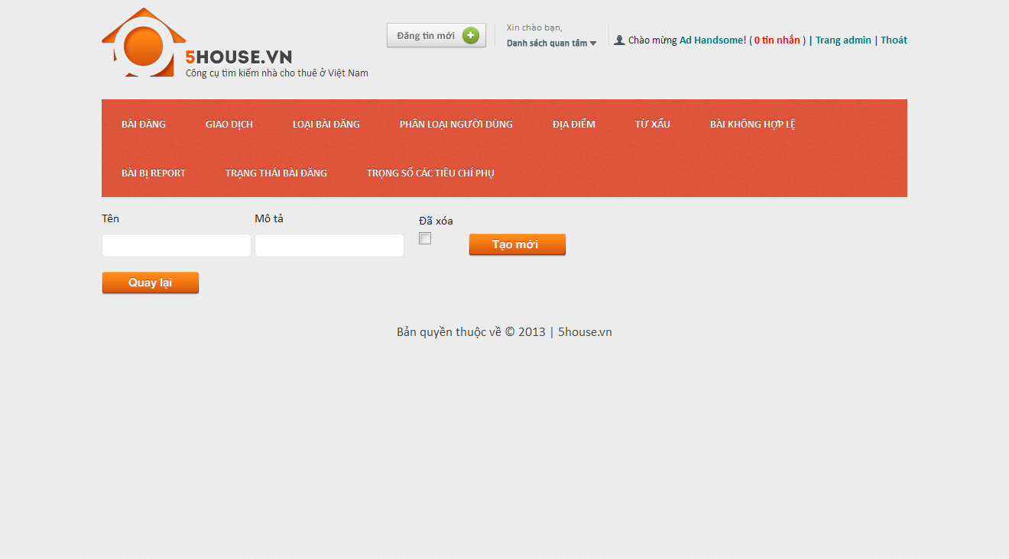

## Edit role

* + - * Login to the system as admin
      * Go to Admin Management page
      * Click on “Phân loại người dùng” tab
      * Click on an item on the table
      * Modify details
      * Click on “Lưu thay đổi” button

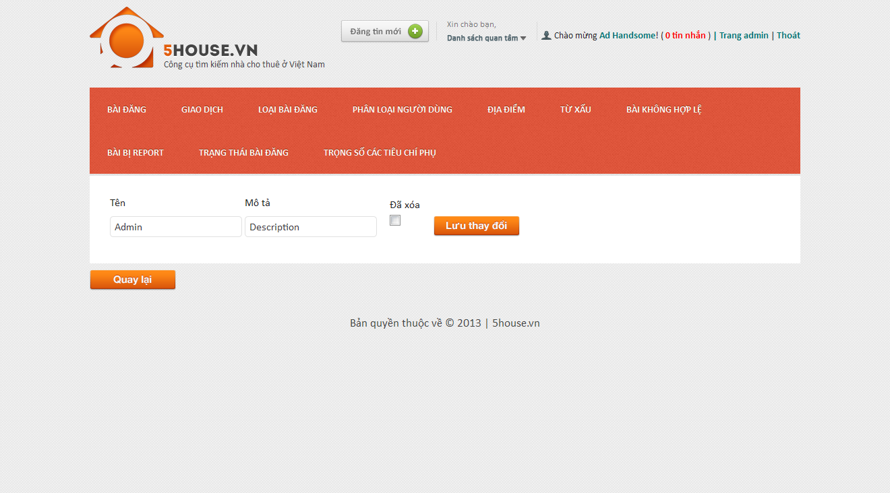

## Manage provinces

## View provinces list

* + - * Login to the system as admin
      * Go to Admin Management page
      * Point on “Địa điểm”
      * Click on “Tỉnh/Thành” tab

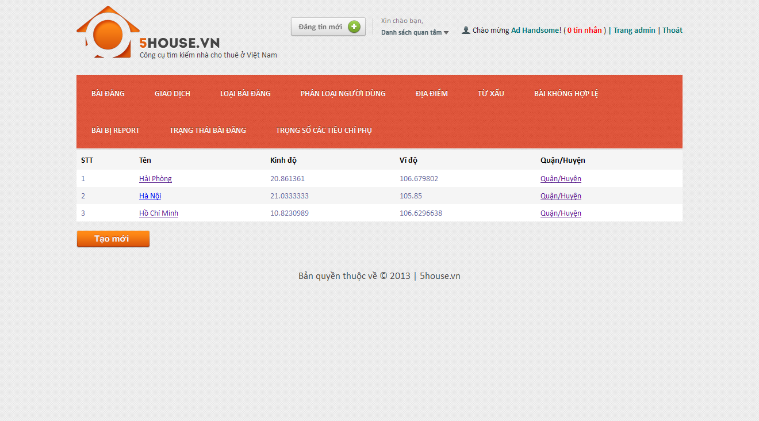

## Add new province

* + - * Login to the system as admin
      * Go to Admin Management page
      * Point on “Địa điểm”
      * Click on “Tỉnh/Thành” tab
      * Click “Tạo mới” button

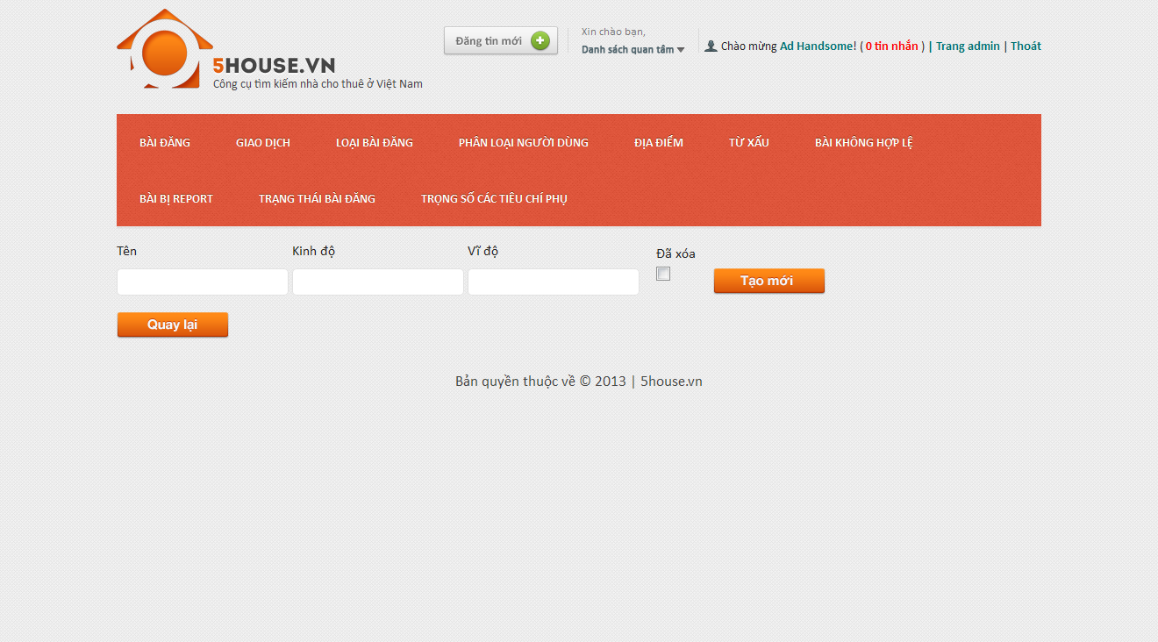

## Edit province

* + - Login to the system as admin
    - Go to Admin Management page
    - Point on “Địa điểm”
    - Click on “Tỉnh/Thành” tab
    - Click on an item on the table
    - Modify details
    - Click on “Lưu thay đổi” button

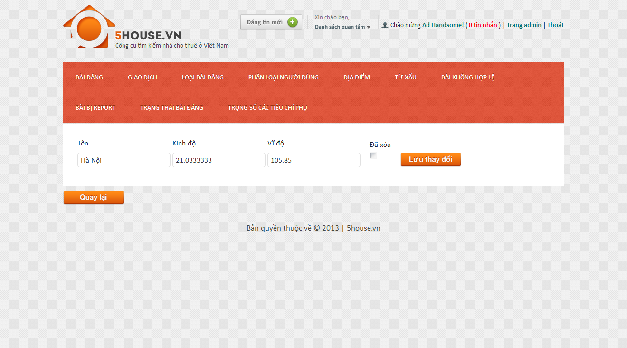

## Manage districts

## View districts list

* + - * Login to the system as admin
      * Go to Admin Management page
      * Point on “Địa điểm”
      * Click on “Quận/Huyện” tab

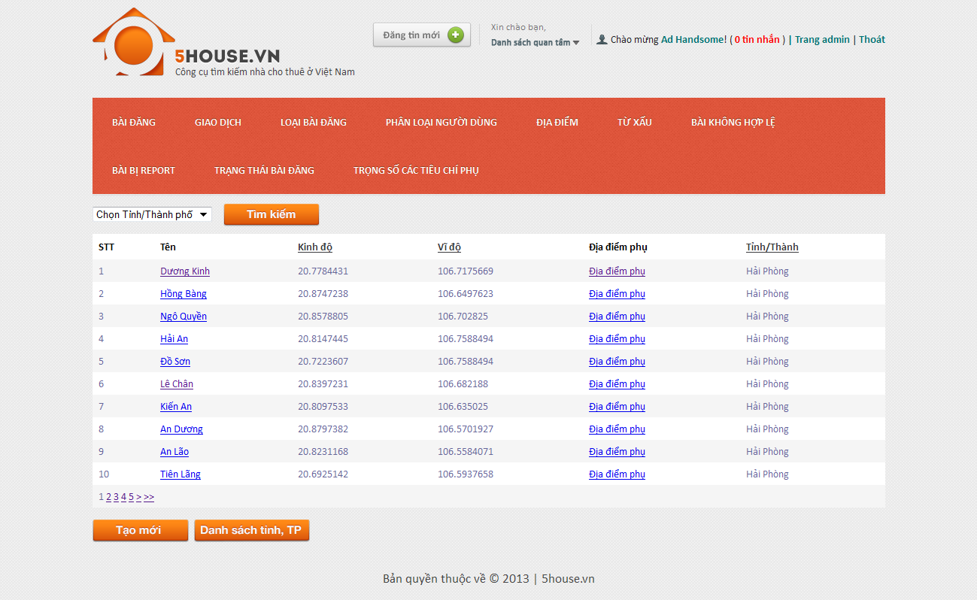

## Add new district

* + - * Login to the system as admin
      * Go to Admin Management page
      * Point on “Địa điểm”
      * Click on “Quận/Huyện” tab
      * Click “Tạo mới” button

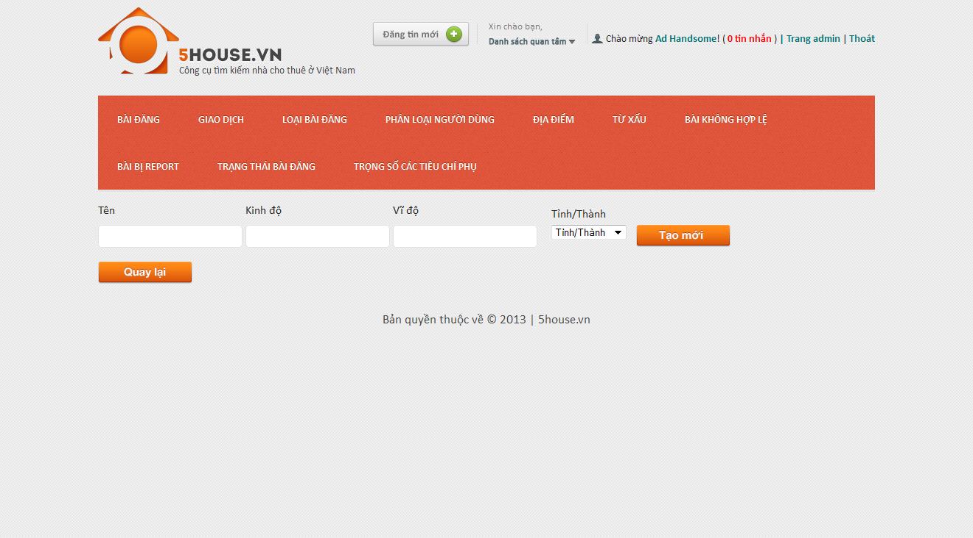

## Edit district

* + - * Login to the system as admin
      * Go to Admin Management page
      * Point on “Địa điểm”
      * Click on “Quận/Huyện” tab
      * Click on an item on the table
      * Modify details
      * Click on “Lưu thay đổi” button

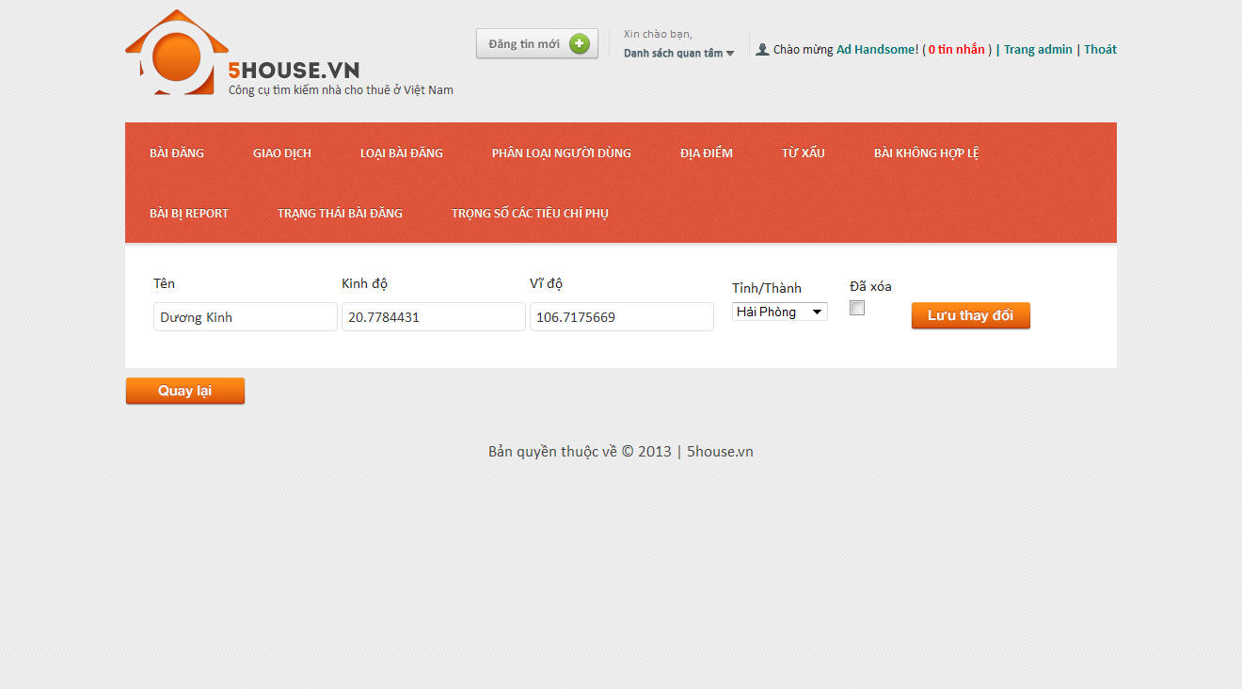

## Manage locations

## View locations list

* + - * Login to the system as admin
      * Go to Admin Management page
      * Point on “Địa điểm”
      * Click on “Địa điểm phụ” tab

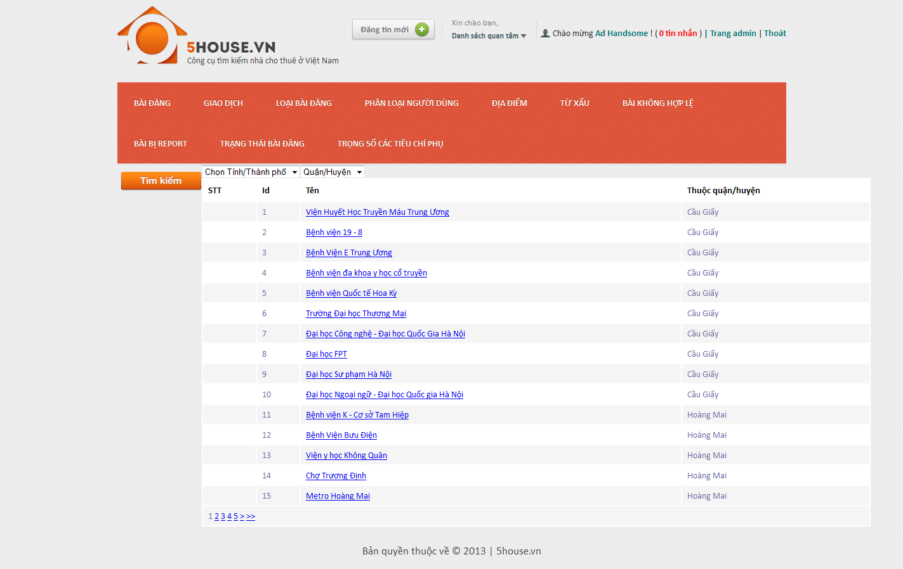

## Add new location

* + - * Login to the system as admin
      * Go to Admin Management page
      * Point on “Địa điểm”
      * Click on “Địa điểm phụ” tab
      * Click “Thêm mới” button

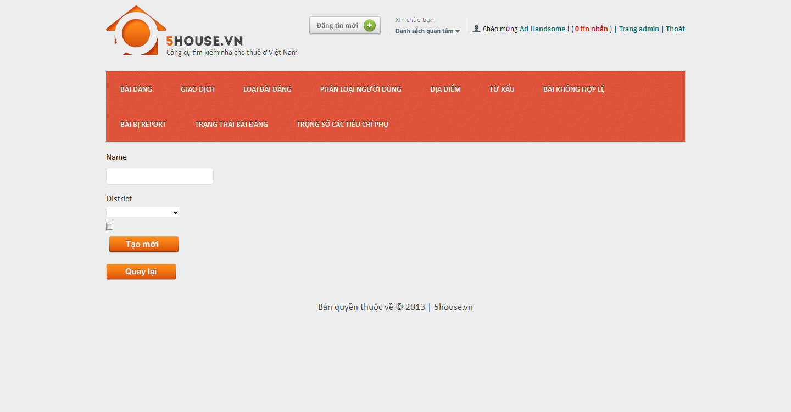

## Edit location

* + - * Login to the system as admin
      * Go to Admin Management page
      * Point on “Địa điểm”
      * Click on “Địa điểm phụ” tab
      * Click on an item on the table
      * Modify details
      * Click on “Lưu thay đổi” button
      * 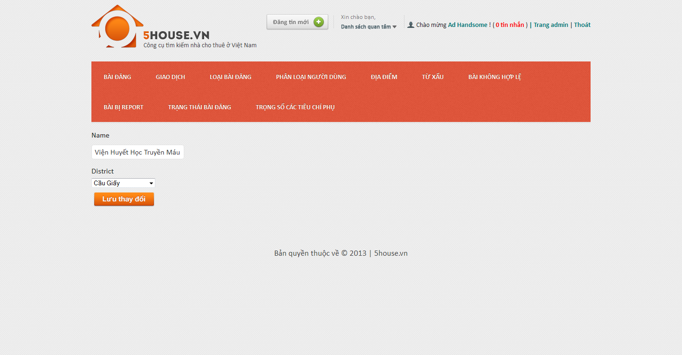

## Manage bad words

## View bad words list

* + - * Login to the system as admin
      * Go to Admin Management page
      * Point on “Từ xấu”
      * Click on “Từ xấu” tab
      * 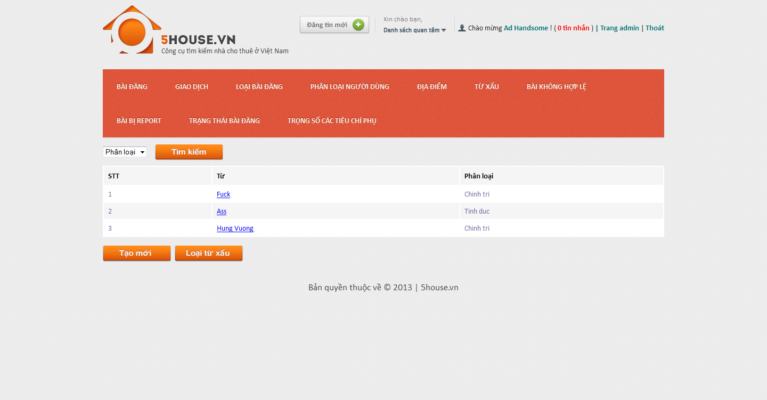

## Add new bad word

* + - * Login to the system as admin
      * Go to Admin Management page
      * Point on “Từ xấu”
      * Click on “Từ xấu” tab
      * Click “Tạo mới” button
      * Enter details as promted
      * Click “Tạo mới” button

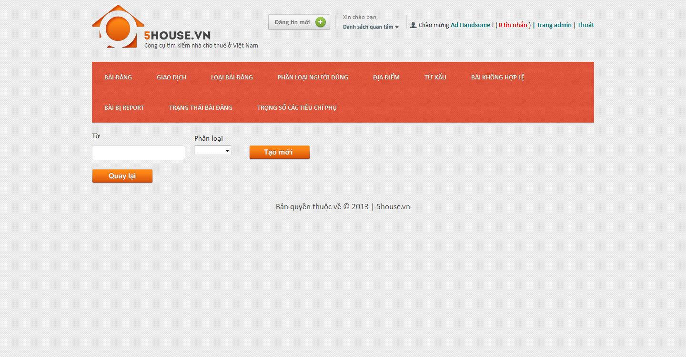

## Edit bad word

* + - * Login to the system as admin
      * Go to Admin Management page
      * Point on “Từ xấu”
      * Click on “Từ xấu” tab
      * Click on an item on the table
      * Modify details
      * Click on “Lưu thay đổi” button

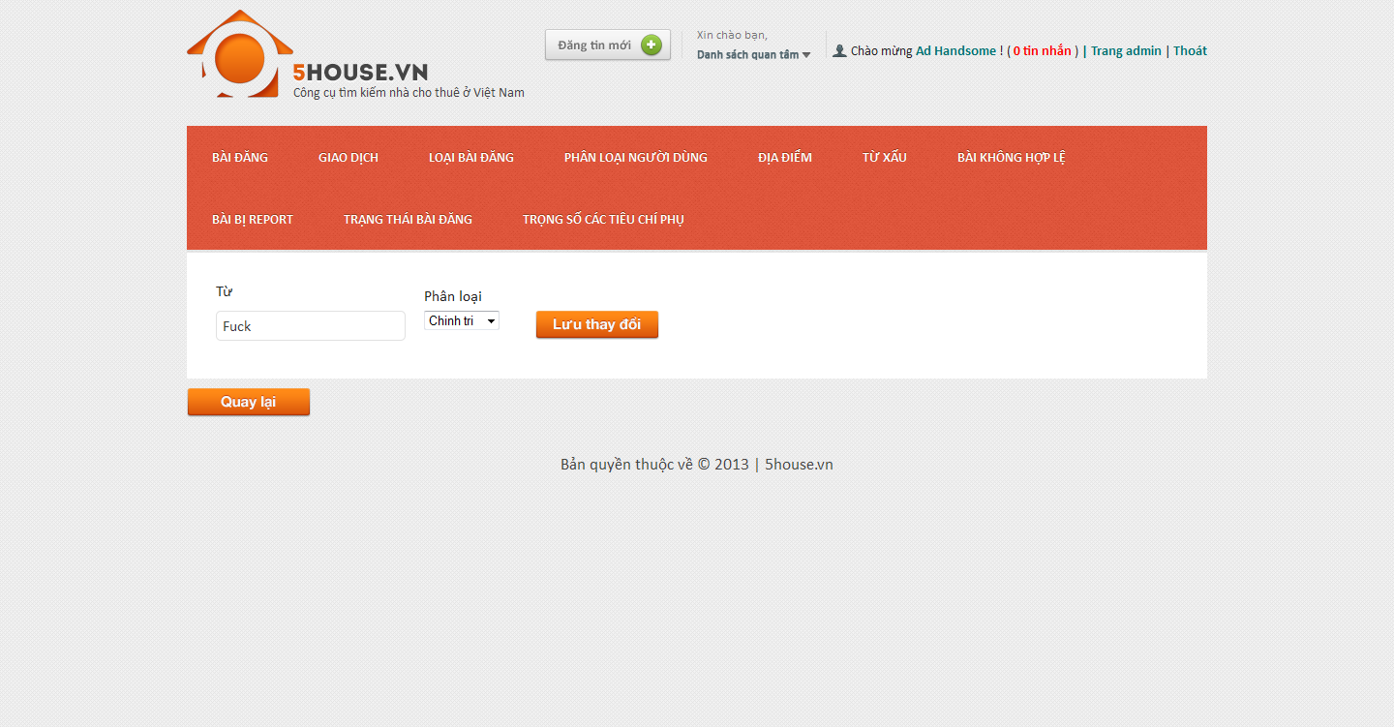

## Manage bad word categories

## View bad word categories list

* + - * Login to the system as admin
      * Go to Admin Management page
      * Point on “Từ xấu”
      * Click on “Phân loại từ xấu” tab

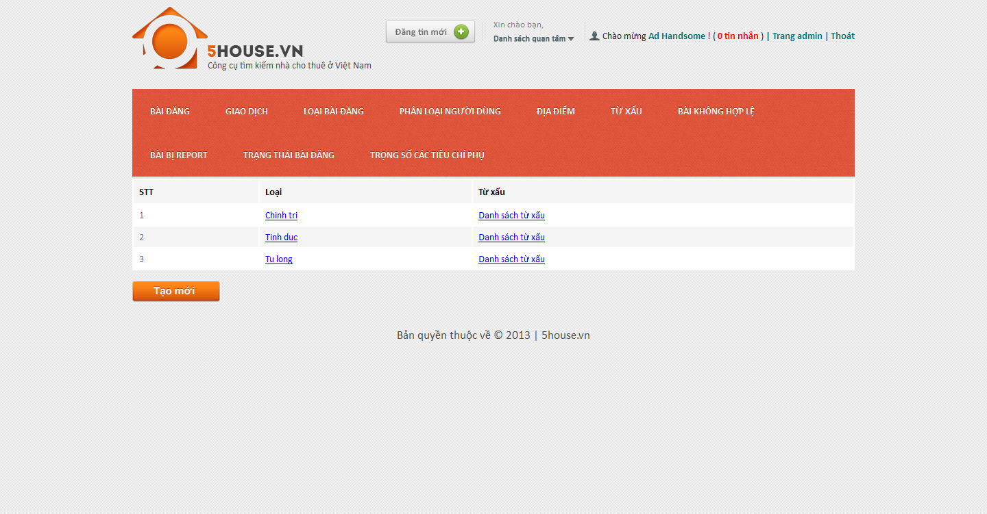

## Add new bad word category

* + - * Login to the system as admin
      * Go to Admin Management page
      * Point on “Từ xấu”
      * Click on “Phân loại từ xấu” tab
      * Click “Tạo mới” button
      * Enter details as promted
      * Click “Tạo mới” button

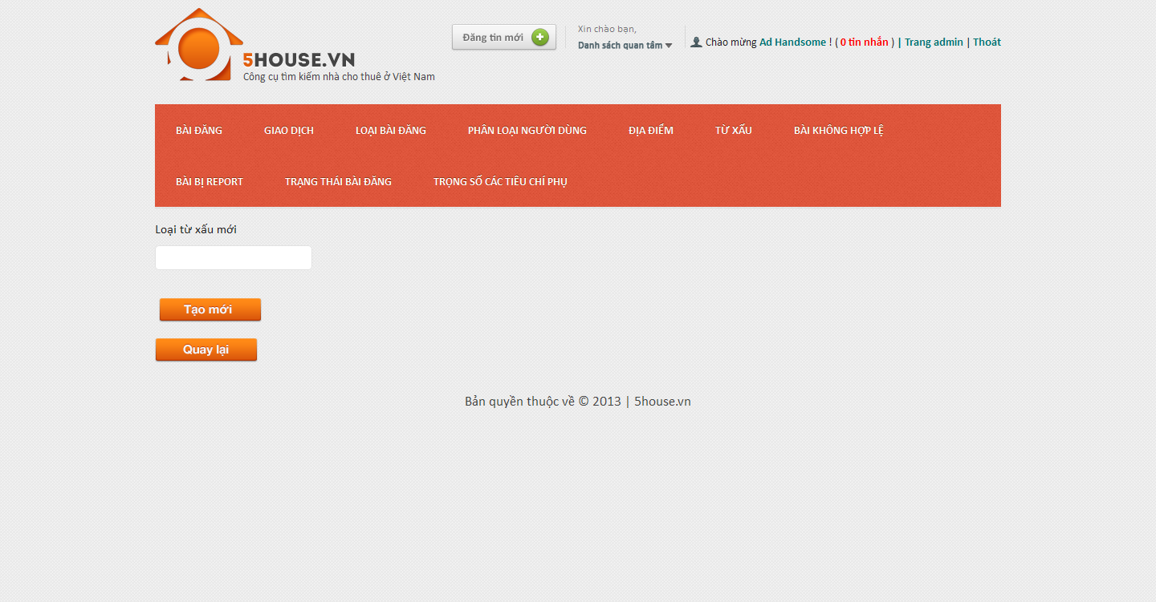

## Edit bad word category

* + - * Login to the system as admin
      * Go to Admin Management page
      * Point on “Từ xấu”
      * Click on “Phân loại từ xấu” tab
      * Click on an item on the table
      * Modify details
      * Click on “Lưu thay đổi” button

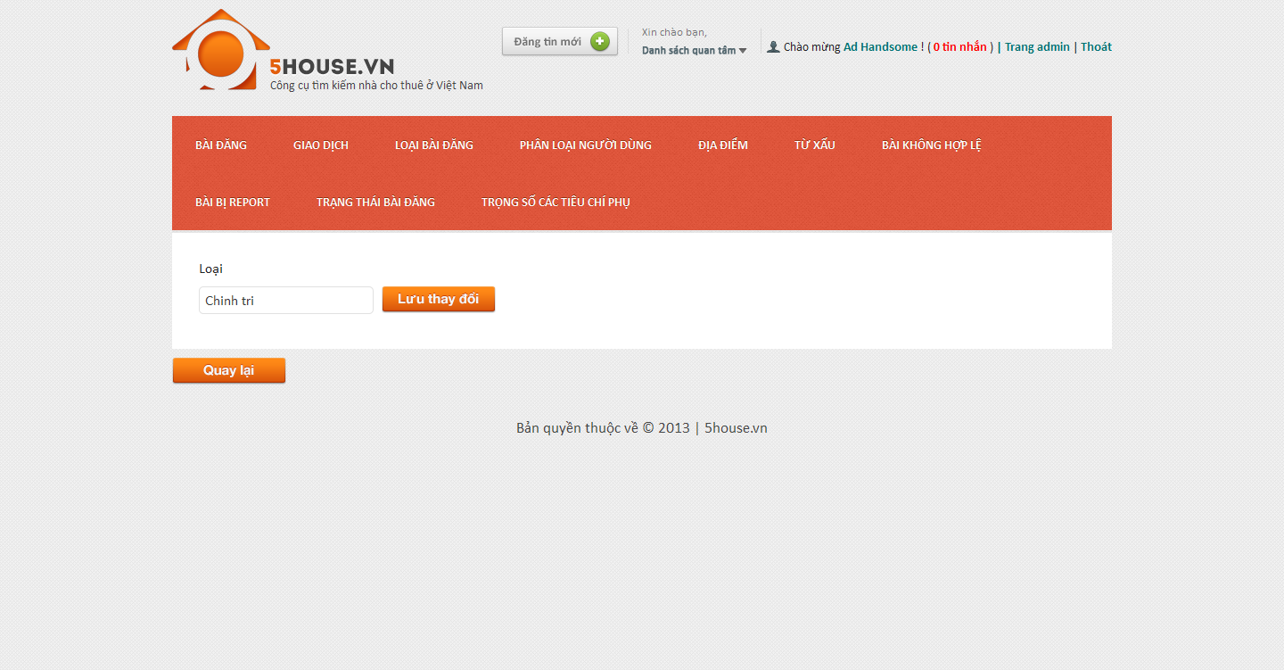

## Manage bad posts

* + - * Login to the system as admin
      * Go to Admin Management page
      * Click on “Bài không hợp lệ” tab
    - 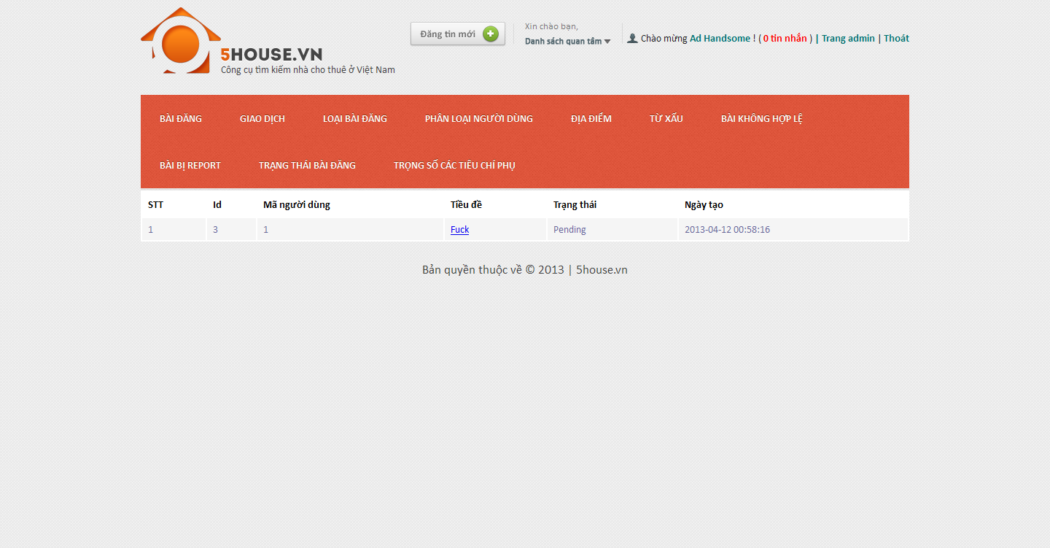

## Manage reported posts

* + - * Login to the system as admin
      * Go to Admin Management page
      * Click on “Bài bị report” tab
    - 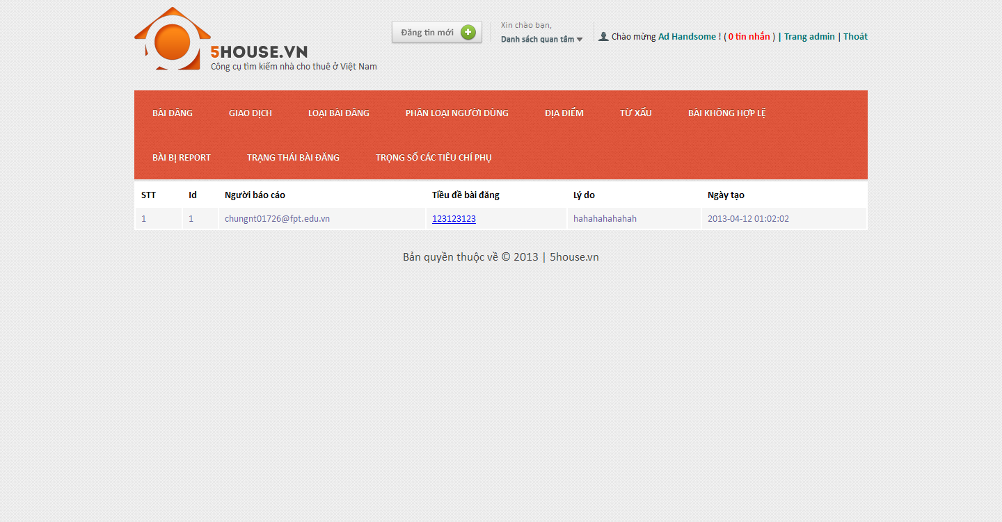

## Manage post statuses

## View post statuses list

* + - * Login to the system as admin
      * Go to Admin Management page
      * Click on “Trạng thái bài đăng” tab
      * 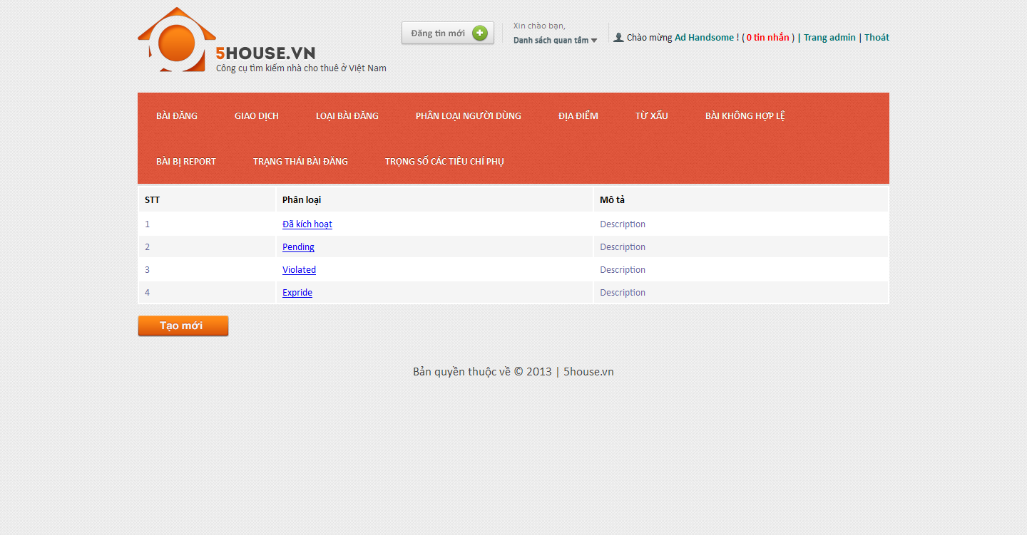

## Add new post status

* + - * Login to the system as admin
      * Go to Admin Management page
      * Click on “Trạng thái bài đăng” tab
      * Click “Tạo mới” button
      * Enter details as promted
      * Click “Tạo mới” button
      * 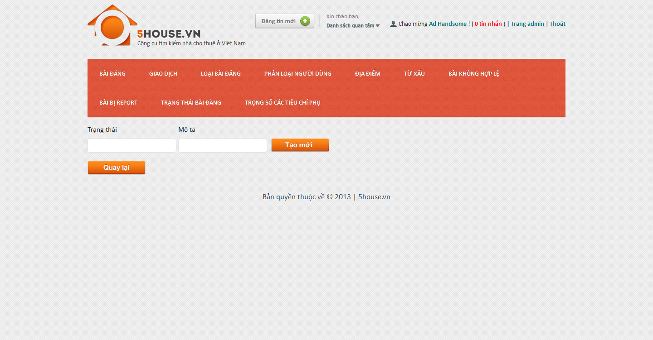

## Edit post status

* + - * Login to the system as admin
      * Go to Admin Management page
      * Click on “Trạng thái bài đăng” tab
      * Click on an item on the table
      * Modify details
      * Click on “Lưu thay đổi” button
      * 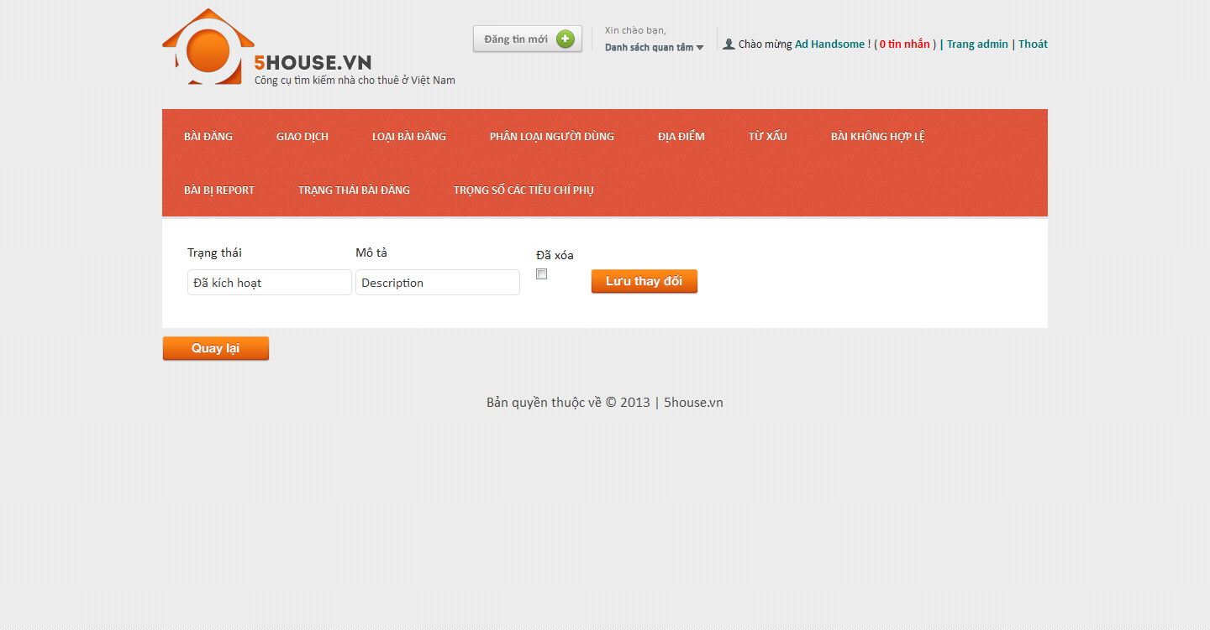

## Manage config score

## View score list

* + - * Login to the system as admin
      * Go to Admin Management page
      * Click on “Trọng số các tiêu chí phụ” tab

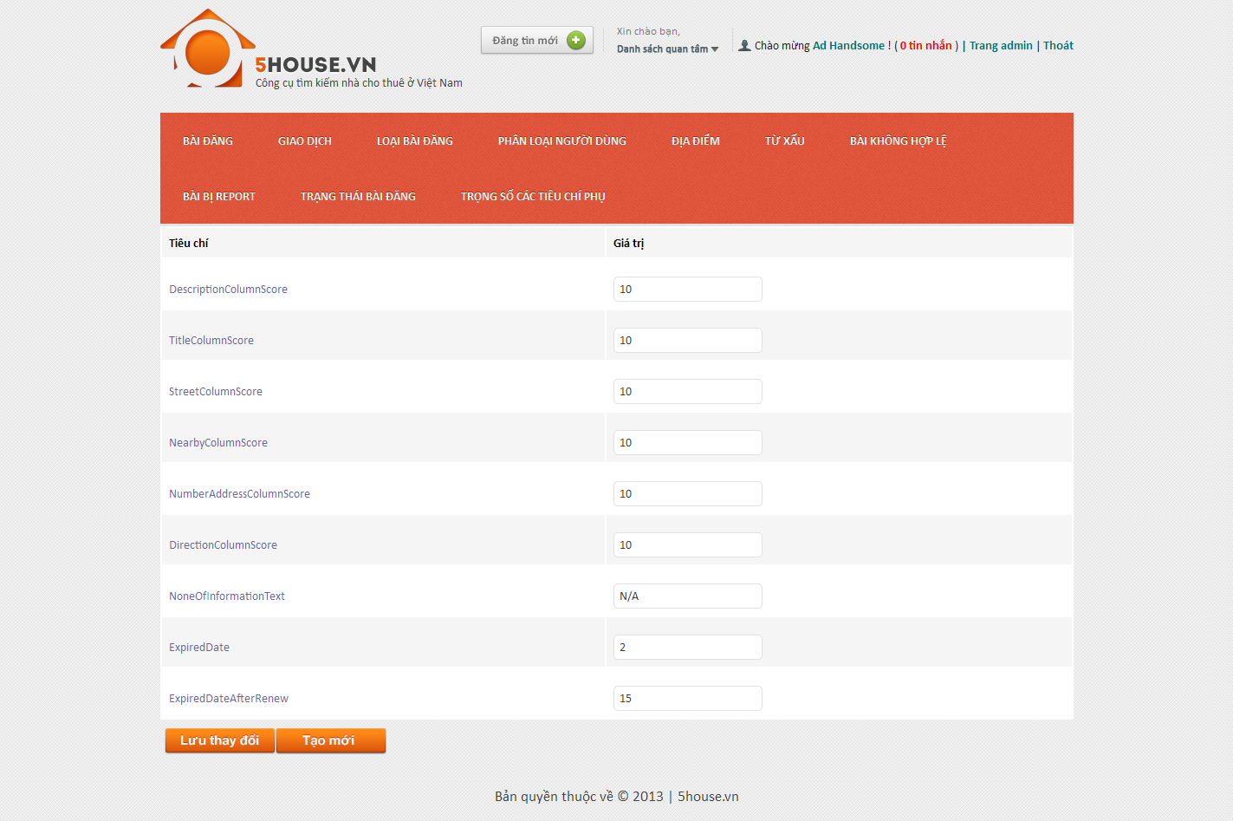

## Edit score value

* + - * Login to the system as admin
      * Go to Admin Management page
      * Click on “Trọng số các tiêu chí phụ” tab
      * Modify values
      * Click on “Lưu thay đổi” button



## Add new score

* + - * Login to the system as admin
      * Go to Admin Management page
      * Click on “Trọng số các tiêu chí phụ” tab
      * Click “Tạo mới” button
      * Enter details as promted
      * Click “Tạo mới” button

